Name: Class:

Task 1
1. Draw a flow diagram for an algorithm which calculates how much money a student will need per week to buy a meal and two drinks each weekday. The user should be prompted to enter how much a meal costs, how much a drink costs, and then calculate and display the total required.

2. Draw a flow diagram for an algorithm which asks someone to enter their age in years. It then calculates the number of days they have been alive. Assume that there are 365 days in each year. You only need to calculate whole years that they have been alive.

Task 2
Jasmine plays a game on her computer screen. A moving balloon appears on the screen, and she has to pop the balloon by clicking on it with the mouse. When the balloon is popped another one appears. The aim of the game is to pop as many balloons as possible in one minute.
The flow diagram for the game is shown below.
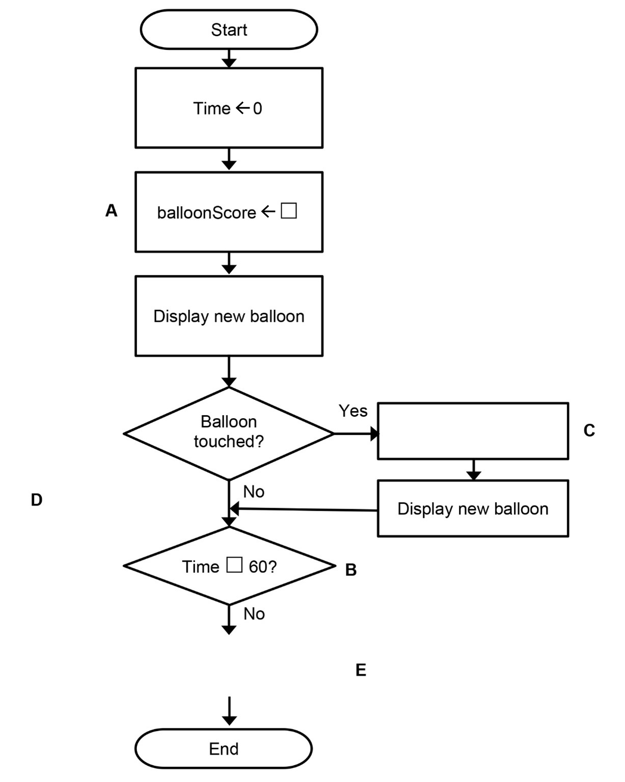
(a) Complete the statement at A.
(b) Complete the statement in B.
(c) Complete the statement at C.
(d) Complete the line and label at D.
(e) Add a flowchart box at the bottom to display the player’s score.
Task 3
Create a flowchart for an algorithm that finds the maximum of three numbers.

Task 4
Michael is writing a program for a dice game played with three dice.
(a) The player rolls the dice, and is given points according to the following algorithm.
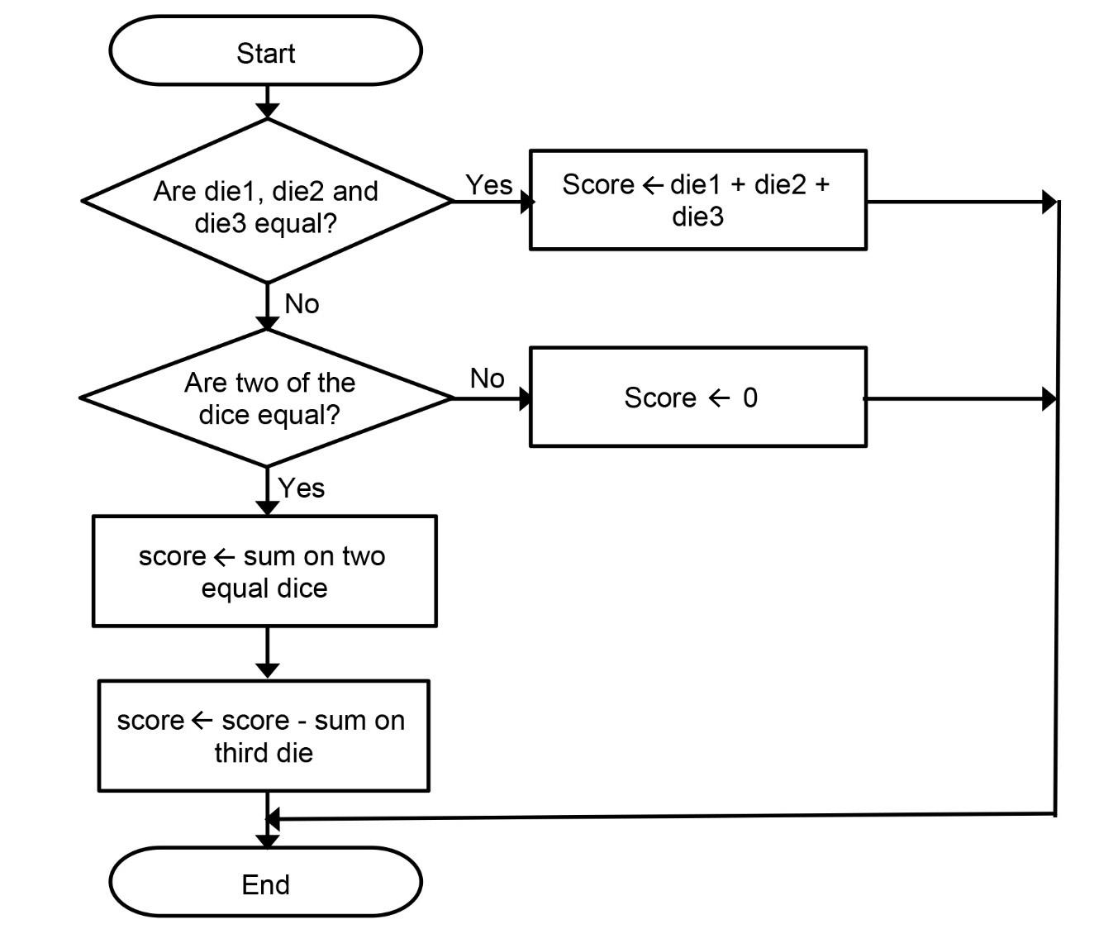

State the value of the scores if the dice rolled are:
246

551

444

(b) Some rolls of the dice produce a negative score. State a set of three numbers that can be used to test whether the algorithm produces a negative score when it should, and state the expected output of your test data.

Task 5
An amusement park operates a smartcard system for visitors. When they enter the park, a visitor chooses the amount they wish to put on their card. Rides cost differing amounts, and to get through a barrier for a particular ride, the visitor inserts their card. The balance on the card is checked. If there is enough money on the card, the balance is updated and displayed and the barrier opens. If there is not enough money left on the card, the current balance is displayed with a message “Not enough for this ride – need to top up”.
Complete the flowchart for the barriers in the amusement park.
